Kendriya Vidyalaya Upper Camp
Dehradun
A Project Report
on
INSTANT MESSENGER
For
AISSCE 2014 Examination
[As a part of the Informatics Practices Course (065)]
SUBMITTED BY
.…………..
Roll No ……………..
Under the Guidance of:
…………….
PGT (Comp.Sc)
CERTIFICATE

This is to certify that the Project / Dissertation entitled INSTANT MESSENGER is a bonafide work done by Master ………. of class XII Session 2013-14 in partial fulfillment of CBSE’s AISSCE Examination 2014 and has been carried out under my direct supervision and guidance. This report or a similar report on the topic has not been submitted for any other examination and does not form a part of any other course undergone by the candidate.

………………………… ……………………………..

Signature of Student Signature of Teacher/Guide

Name: ………. Name: ………………..
Roll No.: …………………… Designation: PGT (Comp.Sc.)

……….…………………

Signature of Principal
Name: ………………….
Place:…………….
Date:……………..

ACKNOWLEDGEMENT
I undertook this Project work, as the part of my XII-Informatics Practices course. I had tried to apply my best of knowledge and experience, gained during the study and class work experience. However, developing software system is generally a quite complex and time-consuming process. It requires a systematic study, insight vision and professional approach during the design and development. Moreover, the developer always feels the need, the help and good wishes of the people near you, who have considerable experience and idea.
I would like to extend my sincere thanks and gratitude to my teacher ……………. I am very much thankful to our Principal Mr……………….. for giving valuable time and moral support to develop this software.
I would like to take the opportunity to extend my sincere thanks and gratitude to my father Sri …….., and my mother Mrs. …………. for being a source of inspiration and providing time and freedom to develop this software project.
I also feel indebted to my friends Mr. ……….. and Mr……….. for the valuable suggestions during the project work.

…………….

Class XII

C O N T E N T S
1. Introduction 1
2. Objective & Scope of the Project 2
3. Theoretical Background 4
4. Problem Definition & Analysis 16
5. System Implementation 22
6.1 The Hardware used: 22
6.2 The Softwares used: 22
6. System Design & Development 23
7.2 Database Design: 24
7.3 Menu Design: 34
7.4 I/O Forms Design & Event Coding: 36
7. User Manual 150
8.1 How to install: 151
8.2 Working with Software: 152
8. References 173

1. Introduction
This software project is developed to automate the functionalities of a Instant Messenger.The purpose of the software project is to develop the Management Information System (MIS) to automate the functioning of a instant messenger capable of sending, receiving messages. Apart from that new user accounts can be added.
A MIS mainly consists of a computerized database, a collection of inter-related tables for a particular subject or purpose, capable to produce different reports relevant to the user. An application program is tied with the database for easy access and interface to the database. Using Application program or front-end, we can store, retrieve and manage all information in proper way.
This software, being simple in design and working, does not require much of training to users .
During coding and design of the software Project, Java NetBeans IDE, a powerful front-end tool is used for getting Graphical User Interface (GUI) based integrated platform and coding simplicity. As a back-end a powerful, open source RDBMS, My SQL is used as per requirement of the CBSE curriculum of Informatics Practices Course.

2. Objective & Scope of the Project
The objective of the software project is to develop a computerized MIS to automate the functions of a messenger This software project is also aimed to enhance the current record keeping system, which will help users to retrieve the up-to-date information.
The proposed software system is expected to do the following functionality-
- To provide a user friendly, Graphical User Interface (GUI) based integrated and centralized environment for MIS activities.
- The proposed system should maintain all the records , and should generate the required reports and information when required.
- To provide graphical and user-friendly interface to interact with a centralized database based on client-server architecture.
- To identify the critical operation procedure and possibilities of simplification using modern IT tools and practices.
In its current scope, the software enables user to retrieve and update the information from centralized database designed with MySQL . This software does not require much training time of the users due to limited functionality and simplicity.
During the development of this project, Java NetBeans IDE, a powerful, open source event-driven form-based development environment is used for modular design and future expandability of the system.
Despite of the best effort of the developer, the following limitations and functional boundaries are visible, which limits the scope of this application software.
1.This is just a model of instant messenger it don’t work over internet as an instant messenger but functions over database to save , retrieve messages and user records.
2.This software can only send messages, can receive messages but is not capable of sending objects like images, video etc.
3.Some application area of a messenger like adding friends, checking validity of an email, isn’t a part of this project.
So far as future scope of the project is concerned, firstly it is open to any modular expansion i.e. other modules or functions can be designed and embedded to handle the user need in future. Any part of the software and reports can be modified independently without much effort.

3. Theoretical Background

3.1 What is Database?

Introduction and Concepts:
A database is a collection of information related to a particular subject or purpose, such as tracking customer orders or maintaining a music collection. Using any RDBMS application software like MS SQL Server, MySQL, Oracle, Sybase etc, you can manage all your information from a single database file. Within the file, divide your data into separate storage containers called tables. You may and retrieve the data using queries.
A table is a collection of data about a specific topic, such as products or suppliers. Using a separate table for each topic means you can store that data only once, which makes your database more efficient and reduces data-entry errors. Table organises data into columns (called fields) and rows (called records).
A Primary key is one or more fields whose value or values uniquely identify each record in a table. In a relationship, a primary key is used to refer to specific record in one table from another table. A primary key is called foreign key when it is referred to from another table.

To find and retrieve just the data that meets conditions you specify, including data from multiple tables, create a query. A query can also update or delete multiple records at the same time, and perform built-in or custom calculations on your data.
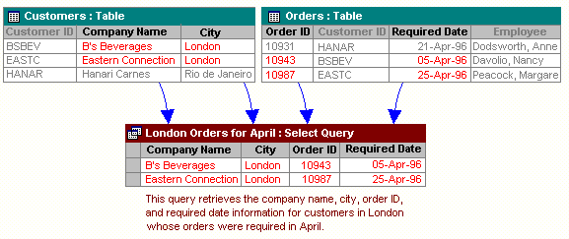

Role of RDBMS Application Program:
A computer database works as a electronic filing system, which has a large number of ways of cross-referencing, and this allows the user many different ways in which to re-organize and retrieve data. A database can handle business inventory, accounting and filing and use the information in its files to prepare summaries, estimates and other reports. The management of data in a database system is done by means of a general-purpose software package called a Database Management System (DBMS). Some commercially available DBMS are MS SQL Server, MS ACCESS, INGRES, ORACLE, and Sybase. A database management system, therefore, is a combination of hardware and software that can be used to set up and monitor a database, and can manage the updating and retrieval of database that has been stored in it. Most of the database management systems have the following capabilities:
- Creating of a table, addition, deletion, modification of records.
- Retrieving data collectively or selectively.
- The data stored can be sorted or indexed at the user's discretion and direction.
- Various reports can be produced from the system. These may be either standardized report or that may be specifically generated according to specific user definition.
- Mathematical functions can be performed and the data stored in the database can be manipulated with these functions to perform the desired calculations.
- To maintain data integrity and database use.
The DBMS interprets and processes users' requests to retrieve information from a database. In most cases, a query request will have to penetrate several layers of software in the DBMS and operating system before the physical database can be accessed. The DBMS responds to a query by invoking the appropriate subprograms, each of which performs its special function to interpret the query, or to locate the desired data in the database and present it in the desired order.

3.2 What is My SQL ? 
The management of data in a database system is done by means of a general-purpose software package called a Database Management System (DBMS). Some commercially available RDBMS are MS SQL Server, MS ACCESS, INGRES, ORACLE, and Sybase. MySQL, the most popular Open Source SQL database management system, is developed, distributed, and supported by Oracle Corporation. MySQL is named after co-founder Monty Widenius's daughter, My. The name of the MySQL Dolphin (our logo) is “Sakila,”.
- MySQL is a database management system.
A database is a structured collection of data. It may be anything from a simple shopping list to a picture gallery or the vast amounts of information in a corporate network. To add, access, and process data stored in a computer database, you need a database management system such as MySQL Server. Since computers are very good at handling large amounts of data, database management systems play a central role in computing, as standalone utilities, or as parts of other applications.
- MySQL is based on SQL.
A relational database stores data in separate tables rather than putting all the data in one big storeroom. This adds speed and flexibility.
- MySQL software is Open Source.
Open Source means that it is possible for anyone to use and modify the software. Anybody can download the MySQL software from the Internet and use it without paying anything.
- The MySQL Database Server is very fast, reliable, and easy to use.
If that is what you are looking for, you should give it a try. MySQL Server also has a practical set of features developed in close cooperation with our users. Its connectivity, speed, and security make MySQL Server highly suited for accessing databases on the Internet.
- MySQL Server works in client/server or embedded systems.
The MySQL Database Software is a client/server system that consists of a multi-threaded SQL server that supports different backends, several different client programs and libraries, administrative tools, and a wide range of application programming interfaces (APIs).

The Main Features of MySQL
- Written in C and C++.
- Works on many different platforms.
- Uses multi-layered server design with independent modules.
- Provides transactional and nontransactional storage engines.
- Designed to make it relatively easy to add other storage engines. This is useful if you want to provide an SQL interface for an in-house database.
- Uses a very fast thread-based memory allocation system.
- Executes very fast joins using an optimized nested-loop join.
- Implements SQL functions using a highly optimized class library that should be as fast as possible. Usually there is no memory allocation at all after query initialization.
- Password security by encryption of all password traffic when you connect to a server.
- Support for large databases. We use MySQL Server with databases that contain 50 million records.
- MySQL client programs can be written in many languages. A client library written in C is available for clients written in C or C++, or for any language that provides C bindings.
- APIs for C, C++, Eiffel, Java, Perl, PHP, Python, Ruby, and Tcl are available, enabling MySQL clients to be written in many languages.
- The Connector/ODBC (MyODBC) interface provides MySQL support for client programs that use ODBC (Open Database Connectivity) connections.

3.3 What is NetBeans IDE ?
NetBeans started as a student project (originally called Xelfi) in the Czech Republic in 1996. The goal was to write a Delphi-like Java IDE in Java. Xelfi was the first Java IDE (Integrated Development Environment) written in Java, with its first pre-releases in 1997. Xelfi was a fun project to work on, especially since Java IDE space was uncharted territory at that time. The project attracted enough interest that these students, once they graduated, decided that they could market it as a commercial product. Soliciting resources from friends and relatives for a web space, they formed a company around it.Soon after, they were contacted by Roman Stanek, an entrepreneur who had already been involved in several startups in the Czech Republic. He was looking for a good idea to invest in, and discovered Xelfi. He met with the founders; they hit it off, and a business was born.
In the spring of 1999, NetBeans DeveloperX2 was released, supporting Swing. The performance improvements that came in JDK 1.3, released in the fall of 1999, made NetBeans a viable choice for development tools. By the summer of 1999, the team was hard at work re-architecting DeveloperX2 into the more modular NetBeans that forms the basis of the software today. Something else was afoot in the summer of 1999: Sun Microsystems wanted better Java development tools, and had become interested in NetBeans. It was a dream come true for the NetBeans team: NetBeans would become the flagship tool set of the maker of Java itself! By the Fall, with the next generation of NetBeans Developer in beta, a deal was struck. Sun Microsystems had also acquired another tools company, During the acqusition, the young developers who had been involved in open-source projects for most of their programming careers, mentioned the idea of open-sourcing NetBeans. Fast forward to less than six months later, the decision was made that NetBeans would be open sourced. While Sun had contributed considerable amounts of code to open source projects over the years, this was Sun's first sponsored open source project, one in which Sun would be paying for the site and handling the infrastructure.

Features of NetBeans
A free, open-source Integrated Development Environment for software developers. You get all the tools you need to create professional desktop, enterprise, web, and mobile applications with the Java platform, as well as C/C++, PHP, JavaScript, Groovy, and Ruby. NetBeans IDE 6.9 introduces the JavaFX Composer, support for JavaFX SDK 1.3, OSGi interoperability, support for the PHP Zend framework and Ruby on Rails 3.0, and more.
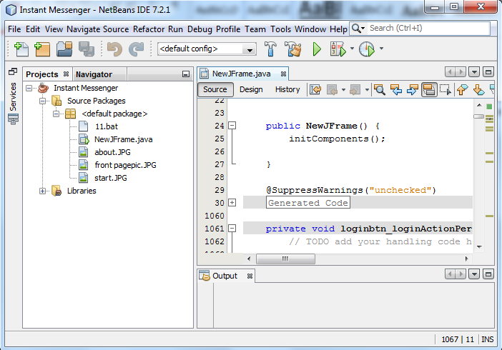

4. Problem Definition & Analysis
The hardest part of building a software system is deciding precisely what to build. No other part of the conceptual work is so difficult as establishing the detailed technical requirement. Defining and applying good, complete requirements are hard to work, and success in this endeavor has eluded many of us. Yet, we continue to make progress.
Problem definition describes the What of a system, not How . The quality of a software product is only as good as the process that creates it. Problem definition is one of the most crucial steps in this creation process. Without defining a problem, developers do not know what to build, customers do not know what to expect, and there is no way to validate that the built system satisfies the requirement.
Problem definition and Analysis is the activity that encompasses learning about the problem to be solved, understanding the needs of customer and users, trying to find out who the user really is, and understanding all the constraints on the solution. It includes all activities related to the following:
- Identification and documentation of user’s needs.
- Creation of a document that describes the external behavior and the association constraints that will satisfies those needs.
- Analysis and validation of the requirements documents to ensure consistency, completeness, and feasibility
- Evolution of needs.
- After the analysis of the functioning of a Instant Messenger, the proposed System is expected to do the following: -
- To provide a user friendly, Graphical User Interface (GUI) based integrated and centralized environment for computerized Instant Messenger.
- The proposed system should maintain all the records , and should generate the required reports and information when required.
- To provide efficient and secured Information storage, flow and retrieval system, ensuring the integrity and validity of records.
- To provide graphical and user-friendly interface to interact with a centralized database based on client-server architecture.
- To identify the critical operation procedure and possibilities of simplification using modern IT tools and practices.

5. System Implementation

5.1 The Hardware used:
While developing the system, the used hardware are:
PC with Pentium IV processor or sometimes, PC with Celeron (1.7 GHz) processor having 256 MB RAM, SVGA and other required devices.

5.2 The Softwares used:
- Microsoft Windows® 7 Professional as Operating System.
- Java NetBeans 6.9 as Front-end Development environment.
- MySQL as Back-end Sever with Database for Testing.
- Microsoft Word 2010 for documentation.

6. System Design & Development

6.1 Database Design:
An important aspect of system design is the design of data storage structure. To begin with a logical model of data structure is developed first. A database is a container object which contains tables, queries, reports and data validation policies enforcement rules or contraints etc. A logical data often represented as a records are kept in different tables after reducing anomalies and redundancies. The goodness of data base design lies in the table structure and its relationship.
This software project maintains a database named PRO which contains the following tables.
The database of PRO contains just two tables. The tables are normalized to minimize the redundancies of data and enforcing the validation rules of the organization.
Table Design:
1.Table : Userdtls
COLUMN | TYPE | SIZE
USER_ID(PRIMARY KEY) | INT | 11
USER_NAME | CHAR | 50
NAME | CHAR | 50
EMAIL | CHAR | 50
PASSWORD | CHAR | 50
2.Table : Msgdtls
COLUMN | TYPE | SIZE
MSGID(PRIMARY KEY) | INT | 11
STATUS | INT | 11
TIME | DATETIME | ~
SENDERID | INT | 11
SENDER | CHAR | 50
SENDERMAIL | CHAR | 50
RECIEVERMAIL | CHAR | 50
RECIEVERID | INT | 11
RECIEVER | CHAR | 25
MSG | BLOB | 65595
RECIEVERMAIL | CHAR | 50
RECIEVERDEL | CHAR | 5
SENDERDEL | CHAR | 5

6.3 I/O Forms Design & Event Coding:
The software project for Instant Messenger contains various forms along with programming codes. Forms (JFrames) and their event coding are given below.
Frame: NewJFrame.java
import java.sql.*
import javax.swing.DefaultListModel;
import javax.swing.JOptionPane;
import javax.swing.table.DefaultTableModel;
public class NewJFrame extends javax.swing.JFrame {
Connection con = null;
Statement stmt = null;
ResultSet rs = null;
String query, mailfrom = null , usrnm, pass, mail;
int usrid=0;
public NewJFrame() {
initComponents();
}
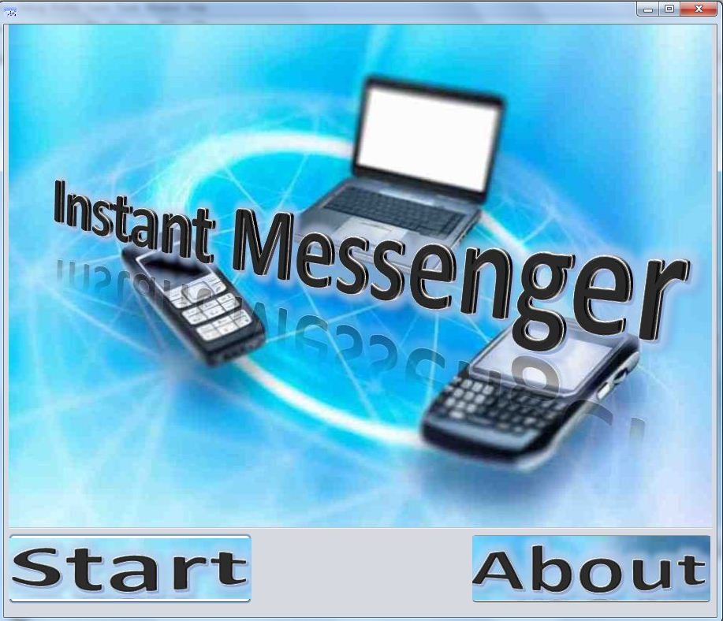
private void startpagebtnActionPerformed(java.awt.event.ActionEvent evt) {
login.setVisible(true);
dispose();
}
private void abtusActionPerformed(java.awt.event.ActionEvent evt) {
abtus_dialog.setVisible(true);
}
Dialog: signup [JDialog]
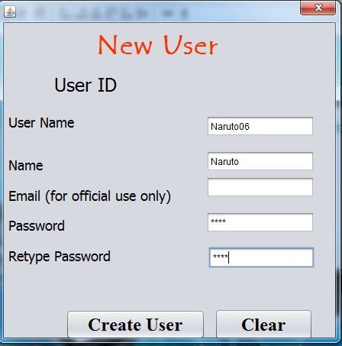

private void createuserbtn_signupActionPerformed(java.awt.event.ActionEvent evt) {
usrnm = inputusrname_signup.getText();
String passwrd = new String(inputpass_signup.getPassword()),
name = inputnametxt_signup.getText(),
email = usrnm+"@kvucmail.in",
retypepasswrd = new String(inputretypepass_signup.getPassword());
if(usrnm!=null && name!=null && passwrd!=null){
int x; //check whether usernm already exists
try {
query = "select count(*) from userdtls where user_name='"+usrnm+"'";
rs = sqlexecutequery(query);
rs.next();
x=rs.getInt("count(*)"); //==> if >0 not valid
if (x==0) {
if(retypepasswrd.equals(passwrd)) {
query = "select max(user_id)+1 from userdtls";
rs = sqlexecutequery(query);
rs.next();
usrid = rs.getInt("max(user_id)+1");
usridlbl_signup.setText("User ID :" + usrid);
query = "insert into userdtls values ("+ usrid + ","+ "'" + usrnm + "'," + "'" +name + "'," +"'" + email +"'," +"'" + passwrd + "'"+ ");";
sqlupdatequery(query);
JOptionPane.showMessageDialog(null, "User Account Created successfully"+'\n'+
" Please note down your user ID: "+ usrid+'\n'+"and your email:" +'\n'+email); inputusermail_signup.setText(""+email); usridlbl_signup.setText("Userid"+usrid);
createuserbtn_signup.setEnabled(false);
}
else{
JOptionPane.showMessageDialog(null, "Your Passwords Don't Match");
}
}
else
{
JOptionPane.showMessageDialog(null, "User name already exists");
}
dispose(); }
catch (Exception e) {
JOptionPane.showMessageDialog(null, e.getMessage());
}
} }
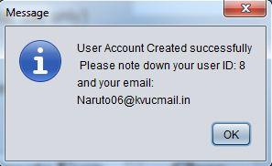
private void clr_signupActionPerformed(java.awt.event.ActionEvent evt) { createuserbtn_signup.setEnabled(true);
inputpass_signup.setText("");
inputusrname_signup.setText("");
inputnametxt_signup.setText("");
usridlbl_signup.setText("User ID");
inputretypepass_signup.setText("");
inputusermail_signup.setText("");
}

Frame: login[JFrame]
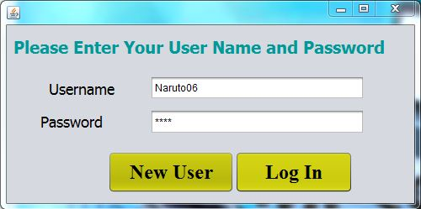
private void newuserbtn_loginActionPerformed(java.awt.event.ActionEvent evt) {
signup.setVisible(true);
inputusermail_signup.setText("");
inputpass_signup.setText("");
inputusrname_signup.setText("");
inputnametxt_signup.setText("");
usridlbl_signup.setText("User ID");
inputretypepass_signup.setText("");
createuserbtn_signup.setEnabled(true);
dispose(); }
private void loginbtn_loginActionPerformed(java.awt.event.ActionEvent evt) {
usrnm = usrnmtxt_login.getText();
pass = new String(usrpass_login.getPassword());
if (usrnm.equals("msgdtls") && (pass.equals("kvuc"))) {
msgdtlspg.setVisible(true); //msgpagelogin
}
else { //userpagelogin
try {
query = "select user_id, password, email, user_name, name from userdtls where user_name =" + "'" + usrnm + "'" + ";";
rs = sqlexecutequery(query);
rs.next();
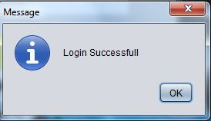
String passwrd = rs.getString("password");
if (pass.equals(passwrd)) { /*login successfull*/
usrid=rs.getInt("user_id");
usrnm=rs.getString("user_name");
mail=rs.getString("email");
JOptionPane.showMessageDialog(null, "Login Successfull");
useridlabel_accsttng.setText("" + rs.getInt("user_id"));
username_welcome.setText(rs.getString("user_name"));
txtnml_accsttng.setText(usrnm);
emaillbll_accsttng.setText(rs.getString("email"));
nm_accsttng.setText(rs.getString("name"));
fromlabel_write.setText(rs.getString("email"));
welcome.setVisible(true);
} }
catch (Exception e) { JOptionPane.showMessageDialog(null,e.getMessage());}
}
login.dispose();
}
Frame: login[JFrame]
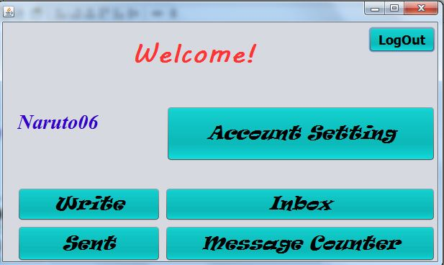
private void Logout3_welcomeActionPerformed(java.awt.event.ActionEvent evt) {
logout(); }
private void accsttngbtn_welcomeActionPerformed(java.awt.event.ActionEvent evt) {
accsttng.setVisible(true); }
private void writebtn_welcomeActionPerformed(java.awt.event.ActionEvent evt) {
write.setVisible(true);
totxt_write.setText("");}
private void inboxbtn_welcomeActionPerformed(java.awt.event.ActionEvent evt) {
inbox.setVisible(true);
msgtextarea_inbox.removeAll();
int status1 = 0;
DefaultListModel x = ( DefaultListModel) msglist_inbox.getModel();
DefaultListModel y = (DefaultListModel) msgidlist_inbox.getModel();
x.removeAllElements();
y.removeAllElements();
try {
query = "Select msgid, senderid , recieverid, time, msg, status , reciever , sender , sendermail "+ "from msgdtls where recieverid= " + usrid +" AND recieverdel = 'no' " +";";
rs = sqlexecutequery(query);
while (rs.next()){
x.add(0,rs.getString("Sender")); y.add(0,rs.getInt("msgid"));
status1= status1 + rs.getInt("status");//check status }
msglist_inbox.setModel(x); msgidlist_inbox.setModel(y);
if (status1 != 0) { //msg for new message
JOptionPane.showMessageDialog(null, "you have recieved" + status1 + " new messages");
}
}
catch (Exception e) {
JOptionPane.showMessageDialog(null, e.getMessage());}
}
private void sentbtn_welcomeActionPerformed(java.awt.event.ActionEvent evt) {
sent.setVisible(true);
try {
DefaultListModel x = ( DefaultListModel) sentmsglist_sent.getModel();
DefaultListModel y = (DefaultListModel) sentmsgidlist_sent.getModel();
x.removeAllElements();
y.removeAllElements();
query = "Select msgid, recieverid, time, msg, status , reciever , sender, recievermail, sendermail from msgdtls where sendermail = '"+ mail +"'"+
" and senderdel = 'no' "+";" ;
rs = sqlexecutequery(query);
while (rs.next()){
x.add(0,rs.getString("reciever"));
y.add(0,rs.getInt("msgid"));
}
sentmsgarea_sent.setText("");
sentmsglist_sent.setModel(x);
sentmsgidlist_sent.setModel(y);
sentmsgidlist_sent.setVisible(false);
}
catch (Exception e) {
JOptionPane.showMessageDialog(null, e.getMessage());
}
}
private void statsbtn_welcomeActionPerformed(java.awt.event.ActionEvent evt) {
msgcounter.setVisible(true);
int avgcharsent ,avgcharrecieved;
try {
query="select count(*), sum(length(msg)) from msgdtls where senderid = "+ usrid+ ";";
rs= sqlexecutequery( query);rs.next(); //max msg send
msgsent_msgcounter.setText(""+rs.getInt("count(*)")); //avg char in msg sent
if(rs.getInt("count(*)")!=0)
{
avgcharsent= rs.getInt("sum(length(msg))") / rs.getInt("count(*)");
}
else {
avgcharsent=0;
}
avgsentmsgchar_msgcounter.setText(""+avgcharsent);
query="select count(*), sum(length(msg)) from msgdtls where recieverid= "+ usrid+";";
rs= sqlexecutequery( query);rs.next();//max msg recieved
msgrecieved_msgcounter.setText(""+rs.getInt("count(*)")); //avg char in recv. msg
if(rs.getInt("count(*)")!=0) {
avgcharrecieved=rs.getInt("sum(length(msg))") /rs.getInt("count(*)");
}
else {
avgcharrecieved=0;
}
avgcharmsgrecieved_msgcounter.setText(""+avgcharrecieved);
}
catch (Exception e) {
JOptionPane.showMessageDialog(null, e.getMessage());
}
}
Frame: accsttng [JFrame]
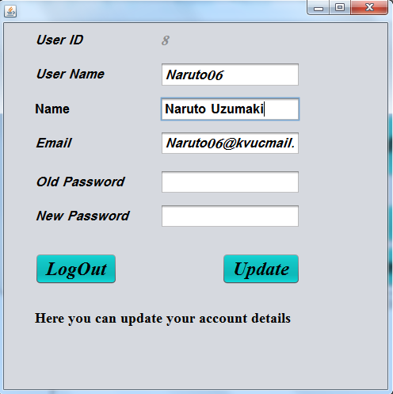
private void Logout7_accsttngActionPerformed(java.awt.event.ActionEvent evt) {
logout(); }
private void Updatel_accsttngActionPerformed(java.awt.event.ActionEvent evt) {
pass = new String(oldpassl_accsttng.getPassword());
String npass = new String(newpassl_accsttng.getPassword()), nm= nm_accsttng.getText();
try {
query = "select user_id, password, email from userdtls where user_name =" +"'" +usrnm + "'"+";";
rs = sqlexecutequery(query); rs.next();
if (pass.equals(rs.getString("password"))) { //check old password
query = "update userdtls set " + "user_name = '" + usrnm + "'"
+ ",name = '" + nm + "'" + ",password = '" + npass + "'"
+ ", email= '" + emaillbll_accsttng.getText() + "'"
+ " where user_id = " + usrid;
sqlupdatequery(query);
JOptionPane.showMessageDialog(null, "Updated Successfully!");
}
else {
JOptionPane.showMessageDialog(null, "Please enter a valid password");
}
}
catch (Exception e) {
JOptionPane.showMessageDialog(null, e.getMessage());
}}
Frame: write[JFrame]
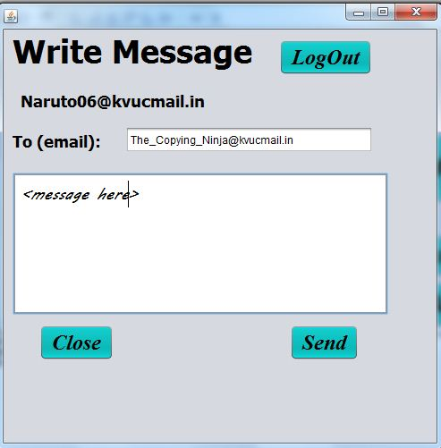
private void Logout5_writeActionPerformed(java.awt.event.ActionEvent evt) {
logout();}
privatevoidClose_writeActionPerformed(java.awt.event.ActionEvent evt) {
write.dispose();
}
private void sendbtn_writeActionPerformed(java.awt.event.ActionEvent evt) {
String mailto, sendermail, reciever, time, msg, sender, recieveremail;
int msgid, senderid, recieverid, status= 1; /*yet not read*/
mailto = totxt_write.getText();
sendermail = fromlabel_write.getText();
senderid = usrid;/*senderid*/
sender = usrnm;/*sender name*/
msg = msgarea_write.getText();/*msg*/
if(msg.equals("") && mailto.equals(""))
{
JOptionPane.showMessageDialog(null, "Can't send a blank mail");}
else{
try {
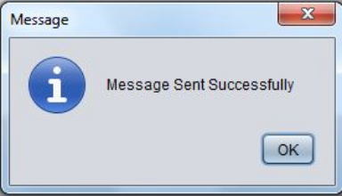
query = "select max(msgid) from msgdtls";
rs = sqlexecutequery(query);
rs.next();
msgid = rs.getInt("max(msgid)") + 1;/*msgid*/
query = "select user_id, user_name , email from userdtls where email= '" + mailto + "'";
rs = sqlexecutequery(query);
rs.next();
reciever = rs.getString("user_name");/*reciever*/
recieverid = rs.getInt("user_id");/*reciever id*/
recieveremail = rs.getString("email");/*reciever email*/
query = "select now()"; /*time*/
rs = sqlexecutequery(query);
rs.next();
time = rs.getString("now()");
query = "insert into msgdtls values ("
+ msgid + "," + status
+ ", '" + time + "'" + "," + senderid + ",'" + sender + "'"
+ ",'" + sendermail + "'"+ "," + recieverid
+ ",'" + reciever + "'"+ ",'" + msg + "'"
+ ",'" + recieveremail + "'," + " 'no', 'no' );";
sqlupdatequery(query);
msgarea_write.setText("");
totxt_write.setText("");
JOptionPane.showMessageDialog(null, "Message Sent Successfully");
}
catch (Exception e) {
JOptionPane.showMessageDialog(null, e.getMessage());
}
}
}

Frame: Sent[JFrame]
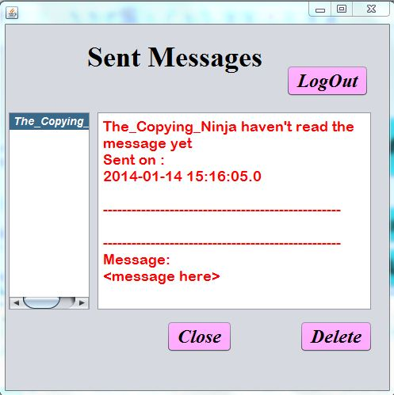
private void Logout6_sentActionPerformed(java.awt.event.ActionEvent evt) {
logout();
}
private void Close_sentActionPerformed(java.awt.event.ActionEvent evt) {
sent.dispose();
}
private void delsentmsg_sentActionPerformed(java.awt.event.ActionEvent evt) {
DefaultListModel dlm1 =(DefaultListModel)sentmsglist_sent.getModel();
DefaultListModel dlm2 =(DefaultListModel)sentmsgidlist_sent.getModel();
Object msgid = sentmsgidlist_sent.getSelectedValue();
if (msgid !=null) {
if (JOptionPane.showConfirmDialog(null, "Are you sure to Delete") ==
JOptionPane.YES_OPTION) {
dlm1.remove(sentmsglist_sent.getSelectedIndex());
dlm2.remove(sentmsgidlist_sent.getSelectedIndex());
sentmsgarea_sent.setText("");
sentmsglist_sent.setSelectedIndex(-1);
sentmsgidlist_sent.setSelectedIndex(-1);
sentmsglist_sent.setModel(dlm1);
sentmsgidlist_sent.setModel(dlm2);
query = "update msgdtls set senderdel = 'yes' where msgid=" + msgid;
sqlupdatequery(query);
}
}
else{
JOptionPane.showMessageDialog(null, "Please select a msg to delete");
}
}
private void sentmsglist_sentValueChanged(javax.swing.event.ListSelectionEvent evt) {
Object msg_id ;
sentmsgidlist_sent.setSelectedIndex( sentmsglist_sent.getSelectedIndex());
msg_id = sentmsgidlist_sent.getSelectedValue();
String br = '\t'+"--------------------------------------------------"+'\n'+
'\t'+"--------------------------------------------------"+'\n';
if(msg_id!=null){
try {
query = "select msgid, status ,reciever, time, sender, sendermail ,msg from msgdtls where msgid = " + msg_id + ";";
rs = sqlexecutequery(query); rs.next();
sentmsgarea_sent.setText("");
if (rs.getInt("status") == 0) {
sentmsgarea_sent.setText(rs.getString("reciever") + " have read the message"+'\n'+"Sent on : " + '\n' + rs.getString("time") + '\n' +br+ "Message:" + '\n' + rs.getString("msg")); }
else {
sentmsgarea_sent.setText(rs.getString("reciever") + " haven't read the message yet"+'\n'+"Sent on : " + '\n' + rs.getString("time") + '\n'+ br + "Message:" + '\n' + rs.getString("msg"));
}
}
catch (Exception e) {
JOptionPane.showMessageDialog(null, "sent msglist"+e.getMessage());
}
}
}
Frame: Inbox[JFrame]
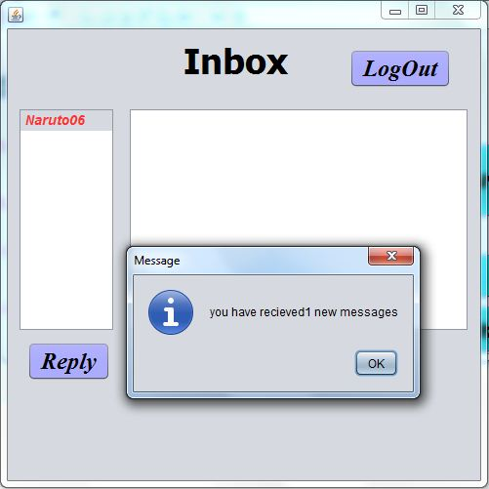
private void Logout8_inboxActionPerformed(java.awt.event.ActionEvent evt) {
logout();
}
private void replybtn_inboxActionPerformed(java.awt.event.ActionEvent evt) {
if (mailfrom== null) {
JOptionPane.showMessageDialog(null, "Please select a msg to reply back;");
} else {
totxt_write.setText(mailfrom);
write.setVisible(true);
}
}
private void Close_sent1ActionPerformed(java.awt.event.ActionEvent evt) {
inbox.dispose();
}
private void Deletebtn_inboxActionPerformed(java.awt.event.ActionEvent evt) {
DefaultListModel dlm1 = (DefaultListModel) msglist_inbox.getModel();
DefaultListModel dlm2 = (DefaultListModel) msgidlist_inbox.getModel();
Object msgid = msgidlist_inbox.getSelectedValue();
if (msgid != null) {
if (JOptionPane.showConfirmDialog(null, "Are you sure to Delete")==
JOptionPane.YES_OPTION) {
dlm1.removeElementAt(msglist_inbox.getSelectedIndex());
dlm2.removeElementAt(msgidlist_inbox.getSelectedIndex());
msgtextarea_inbox.setText("");
mailfrom=null;
msglist_inbox.setSelectedIndex(0);
msgidlist_inbox.setSelectedIndex(0);
query = "update msgdtls set recieverdel = 'yes' where msgid=" + msgid;
sqlupdatequery(query);
}
}
else
{
JOptionPane.showMessageDialog(null, "Please select a msg to Delete");
}
}
private void msglist_inboxValueChanged(javax.swing.event.ListSelectionEvent evt) {
Object msg_id ;
msgidlist_inbox.setSelectedIndex( msglist_inbox.getSelectedIndex());
msg_id = msgidlist_inbox.getSelectedValue();
msgtextarea_inbox.setText("");
String br = '\t'+"--------------------------------------------------"+'\n'+
'\t'+"--------------------------------------------------"+'\n';
if( msg_id!=null){
try {
query = "select msgid, status , time, sender, sendermail ,msg from msgdtls where msgid = " + msg_id + ";";
rs = sqlexecutequery(query);
rs.next();
msgtextarea_inbox.setText("Sent by:"+ rs.getString("sender")+'\n'
+"Email:"+rs.getString("sendermail")+'\n'+"Time:"+rs.getString("time")+'\n'+br+
"Message: "+'\n'+ rs.getString("msg") );
mailfrom=rs.getString("sendermail");
query = "update msgdtls set status = 0 where msgid = " + msg_id + ";"; //status=0==> read
sqlupdatequery(query);
}
catch (Exception e) {
JOptionPane.showMessageDialog(null, e.getMessage());
}
}}
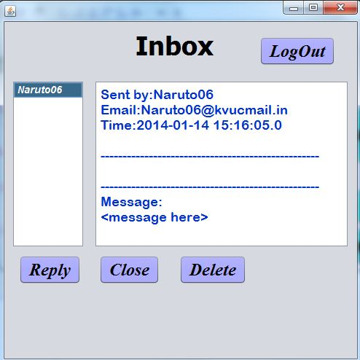
Dialog: msgcounter[JDialog]
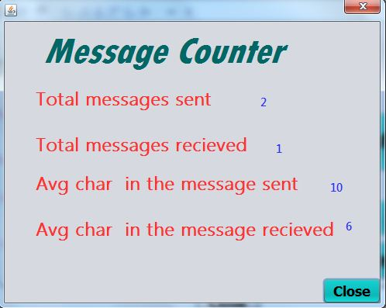
private void close_statsActionPerformed(java.awt.event.ActionEvent evt) {
msgcounter.dispose();
}

Frame: login[JFrame]
private void show_msgdtlsActionPerformed(java.awt.event.ActionEvent evt) {
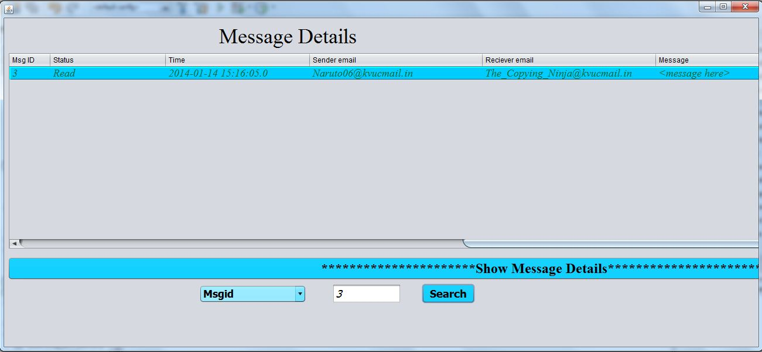
String status;
DefaultTableModel dtm = (DefaultTableModel) msgtbl_msgdtls.getModel();
while(dtm.getRowCount()>0) {
dtm.removeRow(0);
}
try {
query = "select msgid, status, time, sender, sendermail, reciever, msg,recievermail from msgdtls ;";
rs = sqlexecutequery(query);
while (rs.next()){
if(rs.getInt("status") == 1) {
status = "Not Read";
}
else {
status = "Read";
}
dtm.addRow(new Object[] {rs.getInt("msgid"), status, rs.getString("time"), rs.getString("sendermail"), rs.getString("recievermail"), rs.getString("msg")});
}
}
catch (Exception e) {
JOptionPane.showMessageDialog(null, e.getMessage());
} }
private void search_msgdtlsActionPerformed(java.awt.event.ActionEvent evt) {
int opt = sortby_msgdtls.getSelectedIndex();
String val,status;
int val1 ;
DefaultTableModel dtm = (DefaultTableModel) msgtbl_msgdtls.getModel();
while(dtm.getRowCount()>0) {
dtm.removeRow(0);
}
switch(opt) {
case 0: val1 =Integer.parseInt(msgid_txt_msgdtls.getText());
query="select msgid, status, time, sender, sendermail, reciever,msg,recievermail from msgdtls where msgid="+val1+";" ;
break;
case 1 : val=msgid_txt_msgdtls.getText();
query ="select msgid, status, time, sender, sendermail, reciever,msg,recievermail
from msgdtls where sender ='"+val+"';"; break;
case 2 : val=msgid_txt_msgdtls.getText();
query= "select msgid, status, time, sender, sendermail, reciever,
msg,recievermail from msgdtls where reciever ='"+val+"';"; break;
case 3 : val=msgid_txt_msgdtls.getText();
query= "select msgid, status, time, sender, sendermail,
reciever,msg,recievermail from msgdtls where time >'"+val+"';"; break;
case 4 : val=msgid_txt_msgdtls.getText();
query= "select msgid, status, time, sender, sendermail,
reciever,msg,recievermail from msgdtls where time <'"+val+"';"; break;
case 5 : val=msgid_txt_msgdtls.getText();
query= "select msgid, status, time, sender, sendermail,
reciever,msg,recievermail from msgdtls where time='"+val+"';"; break;
default : query= "select msgid, status, time, sender, sendermail,
reciever,msg,recievermail from msgdtls;";
}
try {
rs = sqlexecutequery(query);
while (rs.next()){
if (rs.getInt("status") == 1) {
status = "Not Read";
} else {
status = "Read";
}
Object myrow[] = {rs.getInt("msgid"), status, rs.getString("time"), rs.getString("sendermail"), rs.getString("recievermail"), rs.getString("msg")};
dtm.addRow(myrow);
msgtbl_msgdtls.setModel(dtm);
} }
catch (Exception e) {
JOptionPane.showMessageDialog(null, e.getMessage());
} }
- METHODS USED IN THE PROGRAM
private ResultSet sqlexecutequery(String query) {/*method to execute query*/
try {
Class.forName("java.sql.Driver");
con = DriverManager.getConnection("jdbc:mysql://localhost/pro", "root", "kvuc");
stmt = con.createStatement();
rs = stmt.executeQuery(query);
}
catch (Exception e) {
JOptionPane.showMessageDialog(null, e.getMessage());
}
return rs;
}
private void sqlupdatequery(String query) {/*method to execute update sql query*/
try {
Class.forName("java.sql.Driver");
con = DriverManager.getConnection("jdbc:mysql://localhost/pro", "root", "kvuc");
stmt = con.createStatement();
stmt.executeUpdate(query);
}
catch (Exception e) {
JOptionPane.showMessageDialog(null, e.getMessage());
} }
private void logout(){ //to logout
mailfrom = null ;
usrnm= null;
pass= null;
mail= null;
usrid=0;
//loginframe
usrnmtxt_login.setText("");
usrpass_login.setText("");
//welcome frame
username_welcome.setText("");
//inbox frame
msgtextarea_inbox.setText("");
msglist_inbox.removeAll();
msgidlist_inbox.removeAll();
//writeframe
msgarea_write.setText("");
totxt_write.setText("");
//sentframe
sentmsgarea_sent.setText("");
sentmsglist_sent.removeAll();
sentmsgidlist_sent.removeAll();
//accsttng frame
oldpassl_accsttng.setText("");
newpassl_accsttng.setText("");
//dispose frames and dialogs
welcome.dispose();
inbox.dispose();
write.dispose();
sent.dispose();
accsttng.dispose();
msgcounter.dispose();
signup.dispose();
msgdtlspg.dispose();
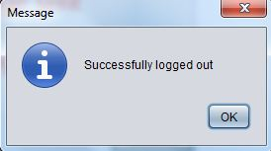
JOptionPane.showMessageDialog(null, "Successfully logged out");
login.setVisible(true);
try{
rs.close();
stmt.close();
con.close();
}
catch(Exception e){
JOptionPane.showMessageDialog(null, e.getMessage());
}
}

7. User Manual

7.1 How to install Software:

Hardware Requirement-
- Intel Pentium/Celeron or similar processor based PC at Client/Server end.
- 128 MB RAM and 4GB HDD space (for Database) is desirable.
- Standard I/O devices like Keyboard and Mouse etc.
- Printer is needed for hard-copy reports.
- Local Area Network(LAN) is required for Client-Server Installation

Software Requirement-
- Windows 2000/XP OS is desirable.
- NetBeans Ver 5.1 or higher should be installed with JDK and JVM.
- MySQL Ver 6.1 with Pro Database must be present at machine.

Database Installation

The software project is distributed with a backup copy of a Database named pro with required tables. Some dummy records are present in the tables for testing purposes, which can be deleted before inserting real data. The project is shipped with pro.SQL file which installs a database and tables in the computer system.

Note: The PC must have MySQL server with user (root) and password (kvuc) . If root password is any other password, it can be changed by running MySQL Server Instance Configure Wizard.

Start Program  MySQL MySQL Server MySQL Server Instance Config Wizard
Provide current password of root and new password as “kvuc” , this will change the root password.
To install a MySQL database from a dump file ( pro.sql) , simply follow the following steps.
Step 1: Copy the Lib.sql file in C:\Program files\Mysql\MySql server 5.1\Bin folder.
Step 2: Open MySQL and type the following command to create the dabase named pro.
mysql> create database pro;
Step 3: Open Command Window (Start Run  cmd)
Step 4: Go to the following folder using CD command of DOS.
C:\Program files\Mysql\MySql server 5.1\Bin>
Step 5: type the following command on above prompt -
C:….\bin> mysql -u root -pkvuc pro < pro.sql
This will create a Library databse with required tables.
8. References
In order to work on this project titled INSTANT MESSENGER, the following books and literature are refered by me during the various phases of development of the project.

(3) http://www.mysql.org/

(4) http://www.netbeans.org/

(6) Informatics Practices for class XII
-by Sumita Arora
(6) Various Websites of Discussion Forums and software development activities.

Other than the above-mentioned books, the suggestions and supervision of my teacher and my class experience also helped me to develop this software project.

